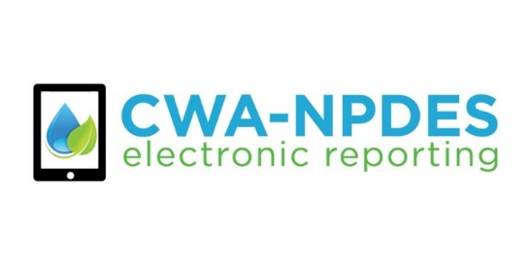

**DRAFT WHITE PAPER No. 1**

**TO:** EPA Regional and Authorized State NPDES Permit and Enforcement Coordinators and State Information Technology Staff

**FROM:** John Dombrowski, P.E., Director

Enforcement Targeting and Data Division (ETDD)

Office of Compliance

US EPA/OECA

**DATE:** 2 November 2016

**SUBJECT:** Draft White Paper No. 1: Public Access to Non-major DMR Data and Compliance Status

**Overview**

This draft white paper supports implementation of the NPDES Electronic Reporting Rule (40 CFR 127) and Next Generation Compliance. Benefits of this proposal include:

* + Simplifying data management tasks for EPA Regions and authorized NPDES programs for non-majors filing Discharge Monitoring Report (DMR) data; and
  + Gradually increasing the visibility of DMR reporting non-receipt violations and permit compliance status for non-majors in a stepwise manner, so as to allow authorized NPDES programs to review their data prior to public release.

In particular, this draft white paper describes how EPA’s NPDES data system (ICIS-NPDES) will handle DMR non-receipt violations for non-majors so that authorized NPDES programs will not need to spend much time addressing erroneous DMR non-receipt violations in ICIS-NPDES. The approach outlined in this white paper provides authorized NPDES programs with sufficient time to share facility and permit data with ICIS-NPDES and to conduct outreach, training, and registration for NetDMR and other electronic reporting tools.

**Draft White Paper No. 1**

**Public Access to Non-major DMR Data and Compliance Status**

EPA is soliciting comment on the following approach for managing DMR non-receipt and quarterly permit compliance status for non-majors. This proposed schedule gives authorized NPDES programs several months to review their data prior to public release and make any necessary changes.

* On 1 January 2017, ECHO Gov (but not ECHO) will start showing all DMR non-receipt violations (for all DMR filers) that occur on or after 1 January 2017. ECHO Gov is only available to EPA and states (not the public). ECHO Gov will also be updated to show the permit compliance status [based on the Reportable Non-Compliance (RNC) Status code] for all facilities for the FY Quarter starting on 1 January 2017 and following FY Quarters. The compliance status for the FY Quarter starting on 1 January 2017 will be available in ECHO Gov approximately 2 ½ months after this quarter has ended. This timeline gives states several months to review their data in ECHO Gov and make any necessary changes. This schedule also provides states with time to train and register non-major DMR filers for electronic reporting.
* On 1 July 2017, ECHO and ECHO Gov will be updated so that they start showing all DMR non-receipt violations (for all DMR filers) that occur on or after 1 July 2017. ECHO and ECHO Gov will be changed to show the permit compliance status (based on the RNC Status code) for all facilities for the FY Quarter starting on 1 July 2017 and following FY Quarters. The permit compliance status for the FY Quarter starting on 1 July 2017 will be available in ECHO and ECHO Gov approximately 2 ½ months after this quarter has ended. ECHO and ECHO Gov will not show any DMR non-receipt violations for non-major facilities that occur prior to 1 July 2017. Additionally, ECHO and ECHO Gov will show the compliance status as “Unknown” for non-majors that only have these DMR non-receipt violations (and no other CWA violations) for FY Quarters prior to 1 July 2017.

Attachment 1 describes EPA’s current method for managing DMR non-receipt violations and permit compliance status for non-major permittees. Attachment 2 provides scenarios that portray how the approach outlined in this white paper will be implemented in ICIS-NPDES, ECHO Gov, and ECHO.

**ACTION REQUESTED:** Comments on this white paper and attachments should be sent to Carey Johnston ([johnston.carey@epa.gov](mailto:johnston.carey@epa.gov)) no later than 5 December 2016.

**TASKS:**

**Step 1:** To implement this proposal, ETDD’s ICIS staff will change the ICIS-NPDES RNC Resolution code to “B” (“Resolved – Manual by EPA/State/Tribal Action”) for all DMR non-receipt violations for non-major permittees on 31 December 2016. See Figure 1 below for a description of how ICIS-NPDES processing of the RNC Resolution code affects permit compliance status.

This mass manual change in the RNC Resolution code will ensure that all DMR non-receipt violations from non-major permittees that occur prior to 1 January 2017 will result in a permit compliance status of “Resolved.” If there are no DMR non-receipt violations for a non-major permittee the permit compliance status code will be blank (i.e., null). ETDD staff will coordinate with EPA Regions and states to identify any permitting authorities that wish to opt out of this task (e.g., currently Arkansas and Louisiana show DMR non-receipt violations for all of their DMR filers).

ETDD staff will also turn permit compliance tracking and DMR non-receipt tracking to “On” for all DMR filers in ICIS-NPDES on 1 January 2017. We will coordinate with ICIS-NPDES users prior to this change to ensure that authorized NPDES programs are aware of this change and can highlight any permittees that should be exempt from this action.

ETDD staff will update the visibility rules in ECHO Gov on 1 January 2017 for DMR non-receipt violations and the corresponding permit compliance status for non-major DMR filers as described above. ECHO Gov will use the ICIS-NPDES permit compliance status code [i.e., the RNC Status code] to show the permittee compliance status.[1]

As described above, ETDD staff will also provide states with an easy method through ECHO Gov to identify permittees that have the permit compliance status code of “D” or “N” due to non-compliance unrelated to DMRs (e.g., non-receipt of compliance schedule reports, single event violations) (see Attachment 1 for a description of the permit compliance status codes of “D” or “N”).

EPA and the states will also be able to use ECHO Gov to identify strengths and weaknesses in NPDES electronic reporting as well as identify the list of permittees that have “DMR Non-Receipt” or “Permit Compliance Tracking Status” set to “Off”. ECHO Gov will also be able to provide the corresponding durations of these “off” statuses. We will update documentation (including data caveats) in ECHO Gov to more fully explain how to interpret a permittee’s compliance status when it is “Unknown”.

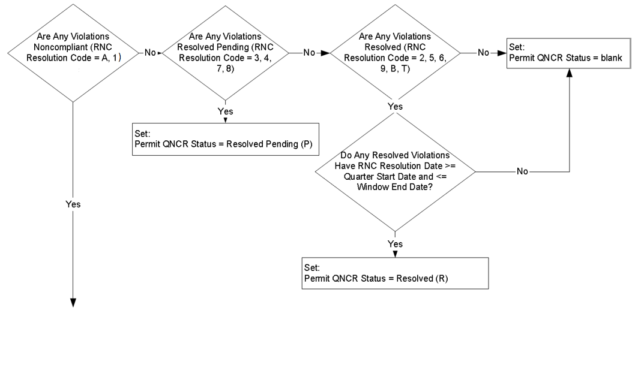

**Figure 1.** Current Processing of RNC Resolution Code.

Source: Figure 9.6-33 - Decision Tree for Determining Automatic Permit QNCR Status, ICIS-NPDES Detailed Design Document. Updated with RNC Processing Technical Design, Version 1.17, 9 July 2013.

This task will be applied to all non-major DMR filers except for specific exceptions that are identified by authorized NPDES programs and shared with EPA. This includes permittees that had their Permit Major/Minor Status Indicator changed from “Major” to “Minor.” Conversely, this task will apply to permittees that had their Permit Major/Minor Status Indicator changed from “Minor” to “Major” but only for the months when the permittee was classified as a “Minor.”

**ACTION REQUESTED:** Permit authorities should send EPA the list of all non-major NPDES IDs that they wish to exclude from the manual resolution of DMR non-receipt violations in ICIS-NPDES. In a separate list, permit authorities should also send EPA the list of non-major NPDES IDs that should be excluded from the task of setting of DMR non-receipt tracking to “On”. These two lists should be sent to Steve Rubin ([rubin.steven@epa.gov](mailto:rubin.steven@epa.gov)) no later than 5 December 2016.

**Step 2:** To implement the second part of this proposal, ETDD staff will change the ICIS-NPDES RNC Resolution code to “B” (“Resolved – Manual by EPA/State/Tribal Action”) for all DMR non-receipt violations for non-major permittees on 30 June 2017. This one-time, mass manual change in the RNC Resolution code will ensure that all DMR non-receipt violations from non-major permittees that occur prior to 1 July 2017 will result in a permit compliance status code of “Resolved.” Similar to Step 1, ETDD staff will coordinate with EPA Regions and states to identify any permitting authorities that wish to opt out of this task (e.g., currently Arkansas and Louisiana show DMR non-receipt violations for all of their DMR filers).

ETDD staff will update the visibility rules in ECHO and ECHO Gov on 1 July 2017 for DMR non-receipt violations and the corresponding permit compliance status for non-major DMR filers as described above. ECHO and ECHO Gov will use the ICIS-NPDES permit compliance status code to show the permittee compliance status. ETDD staff will update its documentation (including data caveats) in ECHO and ECHO Gov to more fully explain how to interpret a permittee’s compliance status when it is “Unknown”.

Finally, ETDD staff will also publish the ‘NPDES Electronic Reporting Readiness and Data Completeness Dashboard’ to ECHO on 1 July 2017 so that EPA, states, and the public will be able to identify strengths and weaknesses in NPDES electronic reporting as well as identify the list of permittees that have “DMR Non-Receipt” or “Permit Compliance Tracking Status” set to “Off” (as well as the corresponding durations of these “off” statuses).

**Attachment 1** - Current ICIS-NPDES, ECHO Gov, and ECHO Processing of

DMR Non-Receipt Data and Quarterly Compliance Status

ICIS-NPDES automatically generates DMR non-receipt violations for all permittees (majors and non-majors). ICIS-NPDES automatically creates “Violation” codes for missing DMR values with monitoring requirements (D80) and missing DMR values with effluent limits (D90). Any DMR value not received within 31 days of the DMR form due date results in the generation of a Violation code (D80 or D90). ICIS-NPDES runs a daily process to identify these DMR non-receipt violations.

In particular, ICIS-NPDES automatically identifies a permittee classified as a “non-major” (a.k.a. “minor”) as having one or more DMR non-receipt violations, even in cases where a state receives the DMR data from a non-major permittee but the state does not share these DMR data with ICIS-NPDES. The previous EPA NPDES data sharing policy, 1985 WENDB, only required authorized NPDES programs to share DMR data with EPA for DMR filers classified as “major.” The 2015 NPDES Electronic Reporting Rule requires states to share all DMR data (majors and non-majors) with EPA. See 40 CFR 127.23.

ICIS-NPDES uses these DMR non-receipt Violation codes (D80 or D90) to generate “RNC Detection” codes [e.g., Non-monthly average DMR value was 30 days overdue (=”K”), DMR monthly average value was 30 days overdue or scheduled report was 30 days overdue (=”N”)]. ICIS-NPDES uses “RNC Resolution” codes to classify the resolution status of these violations (i.e., noncompliant, resolved pending, or resolved). These RNC Resolution codes can be created automatically by ICIS-NPDES or be manually entered by an ICIS-NPDES user.

ICIS-NPDES uses Violation codes, RNC Detection codes, and RNC Resolution codes to create a single compliance status code for each permittee for each FY Quarter. This single compliance status code, updated quarterly, is called the “RNC Status” code. ICIS-NPDES generates this compliance status code approximately 2 ½ months after the quarter has ended and ECHO uses this code to show the permittee’s compliance status for each FY Quarter. The hierarchy of the “RNC Status” code is shown in the table below.

**Table A1-1:** Hierarchy of System Generated Permit RNC Status Codes in ICIS–NPDES

| **Code** | **Status** | **RNC/SNC** | **Description** |
| --- | --- | --- | --- |
| S | Noncompliant | SNC | SNC for Unachieved Schedule Milestone Violation |
| E | Noncompliant | SNC | SNC for Monthly (e.g., 30-Day Average/Daily Average) Effluent Violation |
| X | Noncompliant | SNC | SNC for Non-Monthly (e.g., 7-Day Average/Daily Maximum) Effluent Violation |
| T | Noncompliant | SNC | SNC for Pretreatment Program Report Non-Receipt Violation |
| D | Noncompliant | SNC | SNC for DMR Non-Receipt Violation |
| N | Noncompliant | RNC | RNC for All Non-SNC Violations |
| P | Resolved Pending | N/A | Final Resolution Pending Compliance With Formal Enforcement Action Final Order |
| R | Resolved | N/A | Final Resolution of Violations |
| V | Noncompliant | N/A | Non-RNC Violations in the Quarter. For example, the facility has effluent, compliance schedule, permit schedule, or single-event violations in the current quarter; however, is not considered to be in RNC or SNC. |
| U | Unknown | N/A | Unknown compliance status. |
| <null> | Null in ICIS-NPDES  ‘No Viol’ in ECHO | N/A | Not considered in violation (including RNC/SNC) |

**Sources:** Table 6.1-1. Permit RNC Status Flag Hierarchy, RNC Processing Technical Design, Version 1.17, 9 July 2013. ECHO DFR Data Dictionary. ICIS-NPDES (REF_RNC_STATUS).

ICIS-NPDES users also have the ability to manually override the ICIS-NPDES system generated RNC status codes after the close of the FY Quarter using the following RNC status codes:

* C - Compliant (only manually entered): Facility Should Not Have Appeared on QNCR or Status Code Should Not Have Been Automatically Generated
* Q - Revolved Pending – Compliance Schedule: Revolved Pending – Compliance Schedule (manual only)

As shown above, DMR non-receipt violations initiate a process that sets the RNC status code to “D” or “N”, for the FY Quarter if these violations are not resolved before the end of the FY Quarter. RNC status code “D”, which is Significant Noncompliance (SNC) for majors and Category 1 non-compliance for non-majors, is generated when one or more entire DMRs are in the status of non-receipt.[2] RNC status code “N” is generated when one or more DMR values are in the status of non-receipt.

Additionally, EPA limits the duration for DMR non-receipt violations to affect the RNC Status code. ICIS-NPDES automatically prevents two year old (or older) DMR non-receipt violations from affecting the RNC Status code after two years of no DMR non-receipt violations [i.e., the RNC Resolution Code is set to “0”, which is “Two Years Past Detection (System Administratively Resolved)”]. This helps reduce the number of permittees in SNC due to two year old or older DMR non-receipt violations.

Currently, ECHO does not show the DMR non-receipt violations for non-majors in most states (the exceptions being Arkansas and Louisiana, as requested by these two states). ECHO also only shows the compliance status as “Unknown” for non-majors that only have these DMR non-receipt violations (and no other NPDES violations). The following figures show how ICIS-NPDES displays permit compliance status and DMR non-receipt violations for a non-major facility and how ECHO masks these data.

**Figure A1-1:** ICIS-NPDES Showing RNC Status (including DMR Non-Receipt Violations) for a Non-Major Permittee

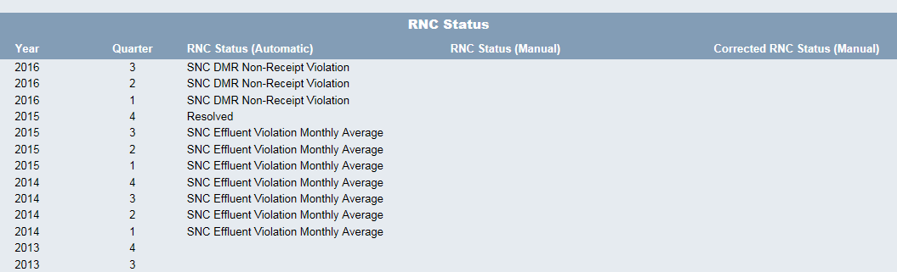

**Figure A1-2:** Example ECHO Detailed Facility Report (DFR) Showing “Unknown” (Grey Box with ‘Unk’) Facility-Level Status (i.e., RNC Status) for the same Non-Major Permittee in Figure A1-1.

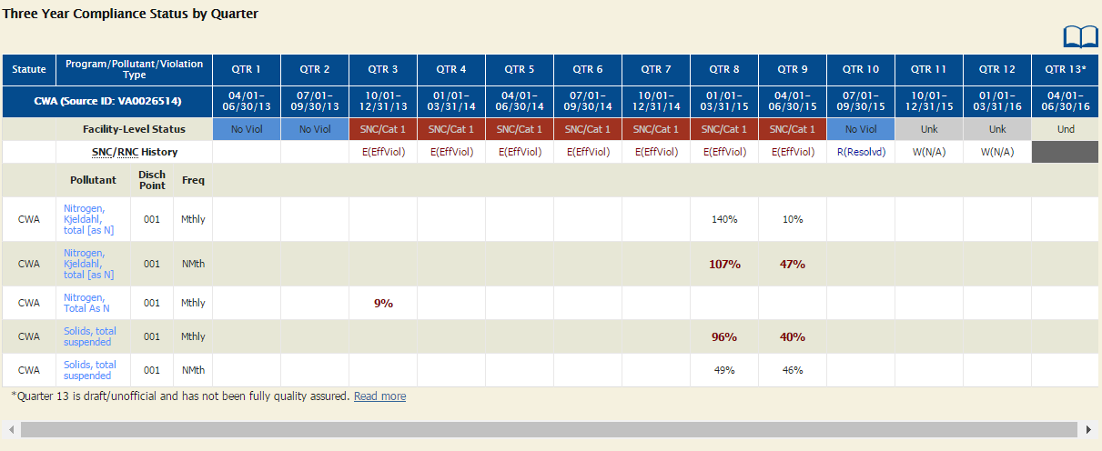

**Attachment 2 – Scenarios Showing RNC Code Changes in ICIS-NPDES, ECHO Gov, and ECHO**





1. The ICIS-NPDES RNC Status code will show the permittee compliance status as “Unknown” when one or both of the “DMR Non-Receipt” or “Permit Compliance Tracking Status” data elements are set to “Off.”
2. ICIS-NPDES process also considers whether a permitted feature has one or more DMR reporting requirements in its DMR non-receipt processing. For example, if a permitted facility has a permitted feature (Outfall 001) with two DMR reporting requirements (001A and 001Q), then ICIS-NPDES would evaluate the DMR reporting requirements for both DMR reporting requirements together. This means that ICIS-NPDES would only generate the RNC status code “D” when both of the DMRs (001A and 001Q) are in non-receipt status for the same reporting period. Using another example, if a permitted facility has two permitted features (Outfall 001 and Outfall 002), each with only one DMR reporting requirement per permitted feature, then ICIS-NPDES would evaluate the DMR reporting requirements for Outfall 001 separately from Outfall 002.

   .